Regional Transport Office Management System

A project submitted to

**UKA TARSADIA UNIVERSITY**

**Bachelor of Science**

**in**

**Information Technology**

By

**Bhautik Sutariya**

201506100110096

**Dolar Bhanderi**

201506100110097

Guided By

**Mr. Hardik Vyas**

**(Assistant Professor)**



**Babu Madhav Institute of Information Technology**

### Uka Tarsadia University

### Bardoli - 394350

**October - 2017**

**CERTIFICATE**



This is to certify that **Bhautik Sutariya (201506100110096), Dolar Bhanderi (201506100110097)** has submitted projectentitled **Regional Transport Office Management** as the partial fulfilment for the award of the degree of Bachelor of Science in Information Technology for 5 Years Integrated M.Sc.(IT) in 2017 – 2018.

**Date:**

**Place:**

|  |  |
| --- | --- |
| **Mr. Hardik Vyas** | **Mr. Jitendra Nasriwala** |
| Guide | Programme Coordinator, |
| (Assistant Professor) |  |
|  | **Babu Madhav Institute of Information Technology** |

**External Examiner**

**Babu Madhav Institute of Information Technology,**

**Uka Tarsadia University,**

**Bardoli - 394350**

**Acknowledgement**

This is to express my deep sense of gratitude to the personalities who have helped me in making the project reality

The training Period was an enriching experience for me from professional as well as personal view by getting and opportunity to familiarize myself to IT industry

I would like to thank and express my sincere gratitude to my project Guide **Mr.** **Hardik Vyas** for his valuable guidance and suggestions to finish the project successfully.

Bhautik Sutariya

Dolar Bhanderi

Integrated Msc(it)

(sem 5)

**Introduction**

**Purpose:**

The System will provide the facility for user to online register in System then apply for learning licenses, driving licenses, check Licenses status.

User can download Question bank for learning licenses exam and also, check the Regional Transport Office details.

Users also get information about traffic rules and regulations, traffic signs.

**Scope:**

Scope of The Regional Transport Office management System User Online Apply Registration, Learning Licenses, Driving Licenses, get The Regional Transport Office details, get Status of Licenses and manage details of Client when they apply for licenses appointment. Presenting information in an easy and Intelligible Manner .it will reduce the difficulties faced on existing system.

**Hardware and Software Requirements**

**Software Requirements:**

Compatible web browser

Operating System: window

**Hardware Requirements:**

Computer or Mobile Device

**System Analysis:**

**1. Identification of Need:**

A total manual system, which is running without any participation of a computer-definitely have its own disadvantages. We know that the production and use of vehicles are increasing day by day. Hence the need of RTO is very important now days.

To know about the problems specifically, we have done a detailed study on the whole procedure of the system which is currently running.

Intermediate persons & institutions will collect more money for license than its fee.

In existing system user cannot check his/her license status. User cannot get any type of alert for license**.**

**Proposed system:**

Issue of information’s about license, which include application forms, demo of leaner’s license test and other information's.

Separate account for the license holders and admin.

Proposed system is an online system so any persons can browse the site and apply for learning license.

Avoid intermediate persons and institutions.

Demo questions of learner’s license test will help the users in their license test.

User can check status of license.

**2. Functional Requirements:**

1. Customer/Staff Login

2. Customer registration

3. Learning Licenses Appointment

4. Driving Licenses Appointment

5. Generate Learning Licenses Report

6. Get the Regional Transport Office Details

7. Check Status of Licenses

8. Maintainability

**3. Non- Functional Requirements:**

1. Portable

2. Performance

3. Security

4. Documentation

**4. Modules:**

**Login:**

Including   Login management of different users. User Creation of different users.

Provide change Password option for users.

**Learning Licenses:**

In Learning Licenses module include the fill the form for learning license and apply

for learning license.

**Driving Licenses:**

In Driving Licenses module learner can apply for driving Licenses.

**Generate Report of Learning Licenses:**

In Generate Report Learning Licenses module a PDF will be generated with user

details if submit learning licenses form.

**The Regional Transport Office Details**

In The Regional Transport Office Details module user can easily search all Regional

Transport Office Details state wise.

**Verification by admin**

In verification by admin Module admin can verify data and change status of license.

**4. User Characteristic:**

**Administrator:**

Administrator is power user. He has the power to verify the data entered by the

User, processing of data and provide appropriate status of licenses, managing of

All the user.

**Authorized user:**

An authorized user should have user name and password to access details

Information from the site exchange for accessing general information about

Licenses status and personal details. A only authorized user can apply for

Learning licenses and driving licenses.

**Visitor:**

He is the person who will visit the website and get general information about

Regional Transport office and download question Bank.

**Use Case Description Form:**

|  |
| --- |
| **Introduction:**  This use case documents the steps that must be followed in order to be RTO management system. |
| **Actors:**  Administrator  Authorized User  Visitor |
| **Precondition:**  The actor must be login in the system before use case begins and it should be valid user. |
| **Postcondition:**  If user successfully login, application will be submitted and database is updated, else system state remain unchanged. |
| **Event Flow**  **Basic Flow:**   1. User login into the system. 2. Display LL and DL form. 3. If all data submitted value should be inserted into database. 4. Learning Licenses Report will be generated. 5. User check license status. |
| **Alternative flow 1: unauthorized user**  If the system does not validate the user than an error message is flag and the use case returns to the beginning of the flow.  **Alternative Flow 2 : Learning License**  This allow user to apply for Learning License and data should be inserted.  **Alternative Flow 3 : Driving License**  This allow user to apply for Driving License and data should be Inserted.  **Alternative Flow 4 : RTO Details**  This allows the user to check RTO Details by state wise.  **Alternative Flow 5 : User exit**  This allows the user to exit any time during the use case. The use case ends. |
| **Special requirement**  None |
| **Associated use case**  Login |

**Use Case Diagrame:**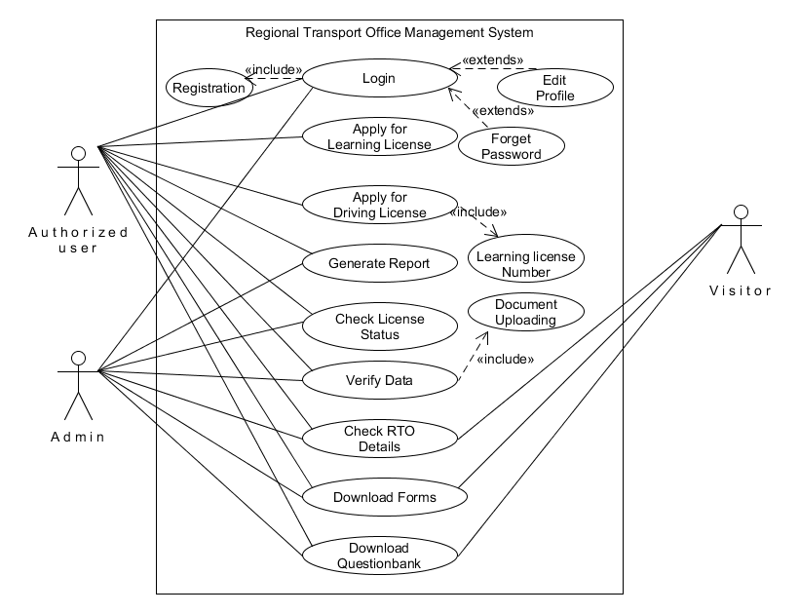

**Activity Diagrame:**

**1. Login**

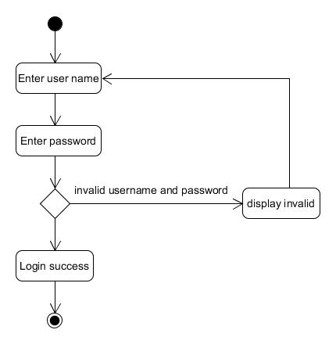

|  |  |
| --- | --- |
| Activity | **Description** |
| Login | This UML describe login activity for admin, authorized user. It required valid username and password |

**2. Learning Licenses:**

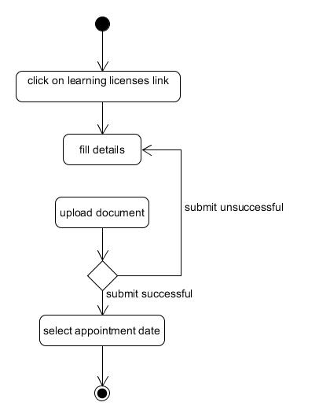

|  |  |
| --- | --- |
| Activity | **Description** |
| Learning Licenses | This UML describe authorized user can get learning licenses form, fill up all details and also get learning licenses appointment date. |

**3.Driving Licenses:**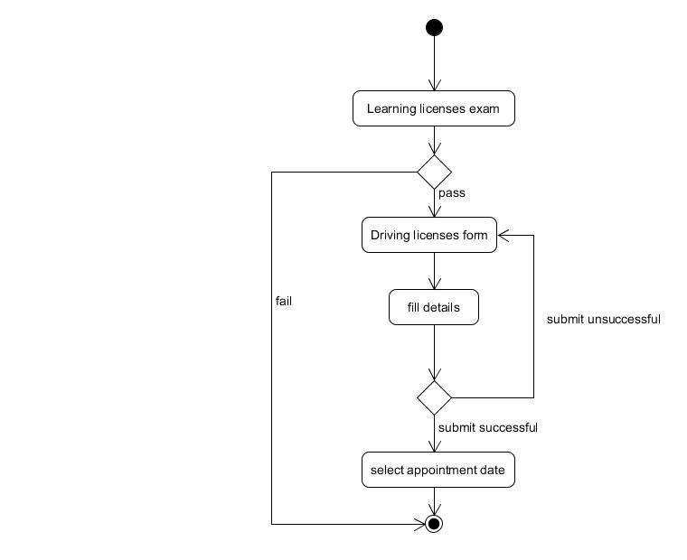

|  |  |
| --- | --- |
| Activity | **Description** |
| Driving Licenses | This UML describe authorized user can get Driving licenses form, fill up all details and also get Driving licenses appointment date. |

**Rto Details:**

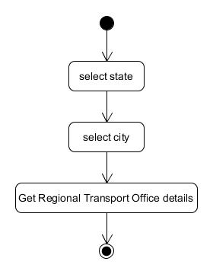

|  |  |
| --- | --- |
| Activity | **Description** |
| Regional Transport Office details | This UML describe admin , visitor,  Authorized user can get information  about Regional Transport Office. |

**Learning Licenses Report:**

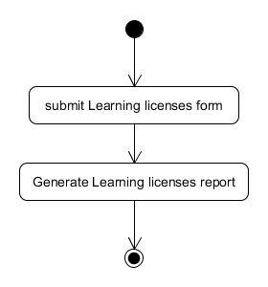

|  |  |
| --- | --- |
| Activity | **Description** |
| Generate Learning Licenses Report | This UML describe authorized user can get learning licenses report. |

**Admin Verification:**

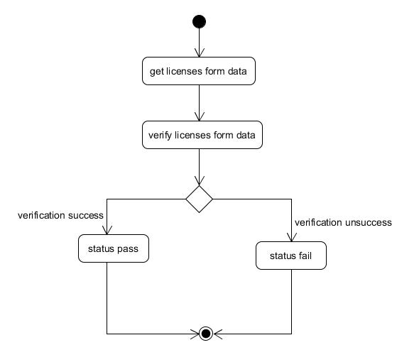

|  |  |
| --- | --- |
| Activity | **Description** |
| Admin verification | This UML describe admin verify licenses form data and change Status pass and fail. |

**Data Dictionary:**

|  |  |  |  |  |
| --- | --- | --- | --- | --- |
| Column name | Description | Data type | Width/size | Constrain |
|  |  |  |  |  |
|  |  | **Registration** |  |  |
| User_ID | Id of every user | Int | 16 bit | Primary key |
| Username | Name of user | Varchar | 20 | Unique constrain |
| Password | Password of user | Varchar | 20 |  |
| Type | Type of user(admin/user) | Boolean | True/false |  |
|  |  |  |  |  |
|  |  |  |  |  |
|  |  | **Learning_license** |  |  |
| LL_ID | LL id | Int | 16 bit | Primary key |
| User_ID | Id of user | Int | 16 bit | Foreign key |
| Fname | First name | Varchar | 15 |  |
| Mname | Middle name | Varchar | 15 |  |
| Lname | Last name | Varhcar | 15 |  |
| Paddress | Permanent address | Varchar | 70 |  |
| Caddess | Commercial address | Varchar | 70 |  |
| Aadhar_Card | Number of aadhar card | Varchar | 12 |  |
| DOB | Date of birth | Date |  |  |
| State_ID | Unique id of state | Int | 16 bit |  |
| RTO_ID | Id of RTO | Int | 16 bit |  |
| Relation | Relation type | Int | 16 bit |  |
| R_First_name | First name of relational | Varchar | 15 |  |
| R_Last_Name | Last name of relational | Varchar | 15 |  |
| R_Middle_Name | Middle name of Relational | Varchar | 30 |  |
| Gender | Gender of user | Boolean | True/false |  |
| Mobile_no | Mobile no | Varchar | 13 |  |
| Age | Age of user | Int | 16 bit |  |
| Country_ID | County of user | Int | 16 bit |  |
| City_status | Status of city | Int | 16 bit |  |
| Blood_group | Blood group | Varchar | 3 |  |
| Email | Email | Varchar | 35 |  |
| Education | Education of user | Varchar | 35 |  |
| Outside_india_month | No of month in india | Int | 16 bit |  |
| Outside_india_year | No of year in india | Int | 16 bit |  |
| Vehicle_type | Type of vehicle | Int | 16 bit |  |
| Status | Status of license | Int | 16 bit |  |
| Appointment_date | Date of appointment | Date |  |  |
|  |  |  |  |  |
|  |  | **Driving_License** |  |  |
| DL_ID | id of DL | Int | 16 bit | Primary key |
| User_ID | id of user | Int | 16 bit | Foreign key |
| Valid_til | Validity of license | Date |  |  |
| Status | Status of DL | Int | 16 bit |  |
| Appointment_date | Date of appointment | Date |  |  |
|  |  | **FileUpolad** |  |  |
| User_ID | id of user | Int | 16 bit | Foreign key |
| Address_path | Path of address proof | Varchar | 20 |  |
| Age_path | Path of age proof | Varchar | 20 |  |
|  |  |  |  |  |
|  |  | **Report_log** |  |  |
| Report_ID | Id of report | Int | 16 bit | Primary key |
| User_ID | id of user | Int | 16 bit | Foreign key |
| Report_Date | Date of report | Date |  |  |
| Report_time | Time of report | Time |  |  |
|  |  |  |  |  |
|  |  |  |  |  |
|  |  | **CITY** |  |  |
| City_ID | Id of city | Int | 16 bit | Primary key |
| State_ID | Id of state | Int | 16 bit | Foreign key |
| City_name | Name of city | Varchar | 15 |  |
|  |  |  |  |  |
|  |  | **STATE** |  |  |
| State_ID | Id of state | Int | 16 bit | Primary key |
| Country_ID | Id of country | Int | 16 bit | Foreign key |
| State_name | Name of state | Varchar | 20 |  |
|  |  |  |  |  |
|  |  |  |  |  |
|  |  | **Country** |  |  |
| Country_ID | Id of country | Int | 16 bit | Primary ley |
| Country_name | Name of country | Varchar | 20 |  |
|  |  |  |  |  |
|  |  | **RTO_Details** |  |  |
| RTO_ID | Id of rto | Int | 16 bit | Primary key |
| State_ID | Id of state | Int | 16 bit | Foreign key |
| City_id | Id of city | Int | 16 bit | Foreign key |
| Address | Address of RTO | Varchar | 70 |  |
|  |  |  |  |  |

**User Interface Design:**

**Home Page**

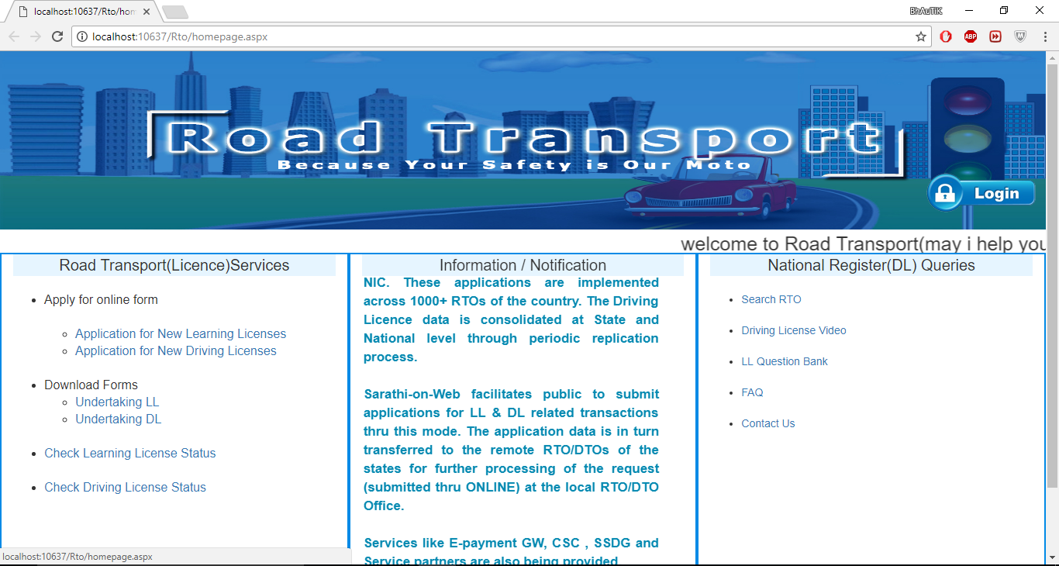

**Login:**

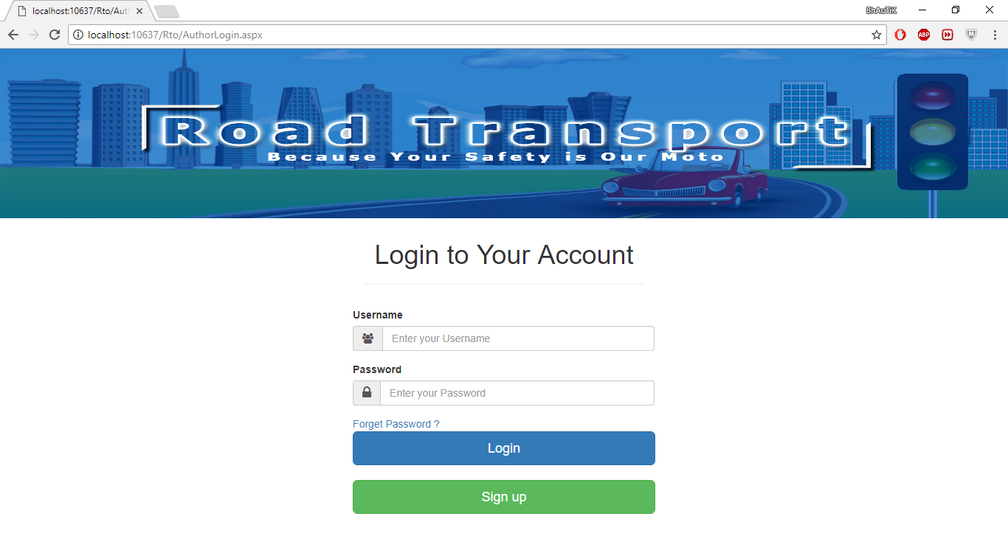

**Registration:**

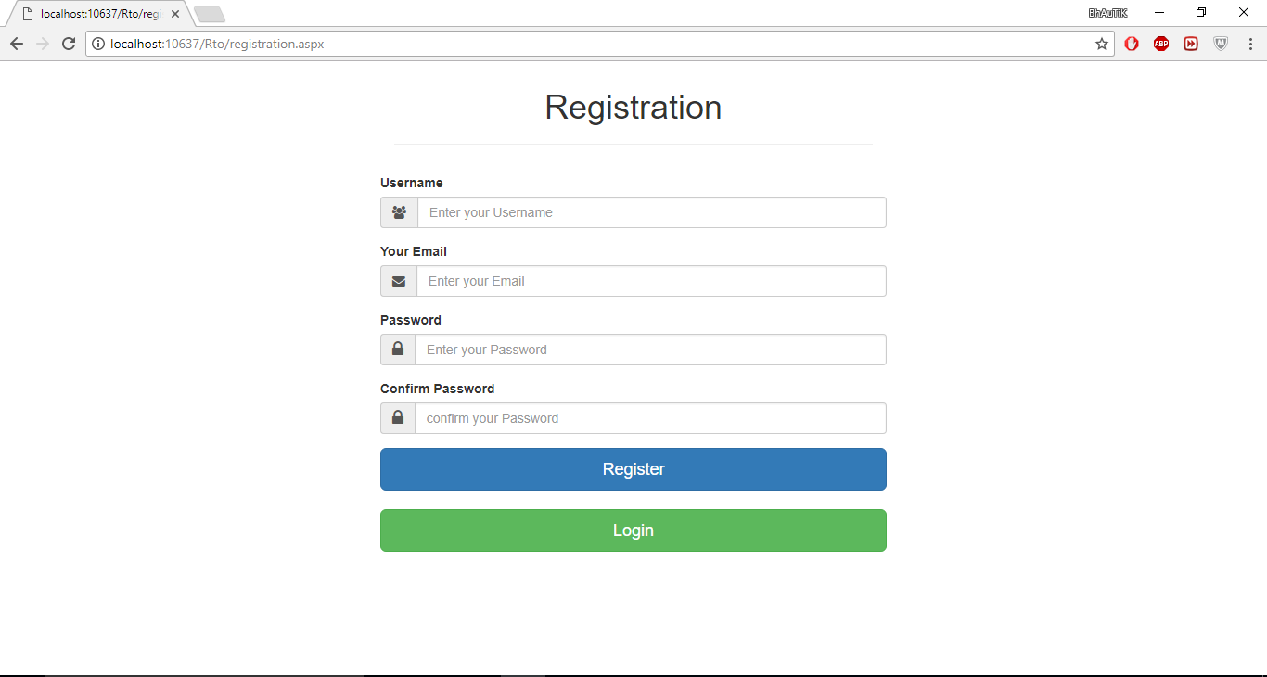

**Learning Licenses:**

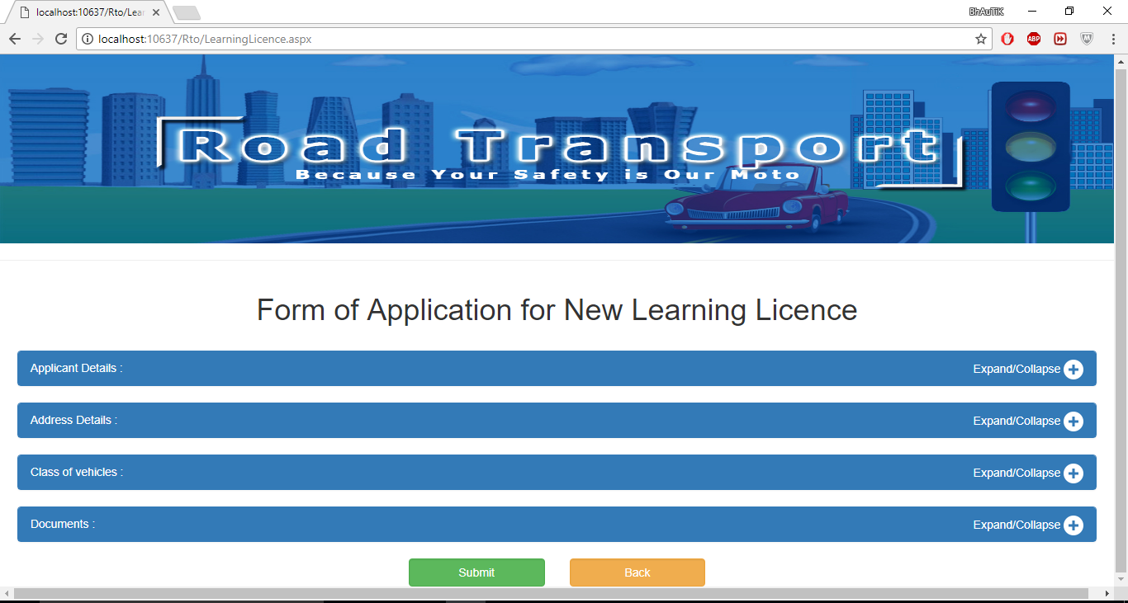

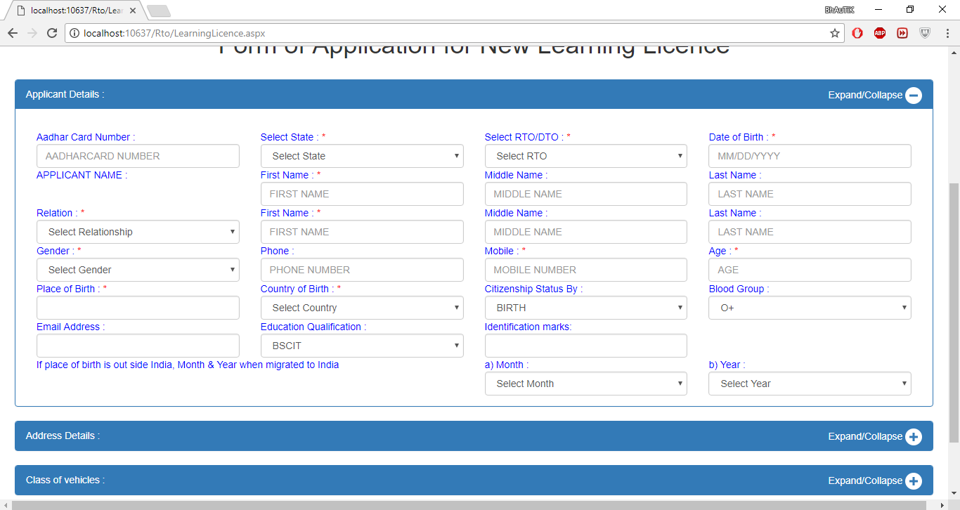

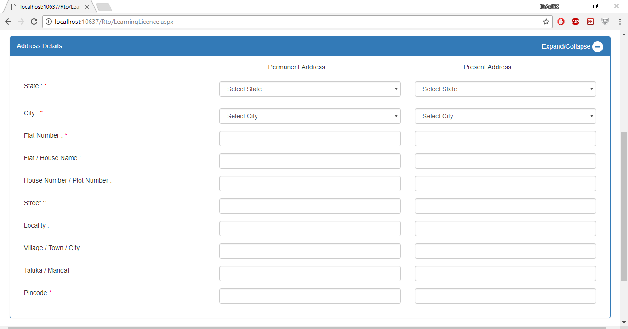

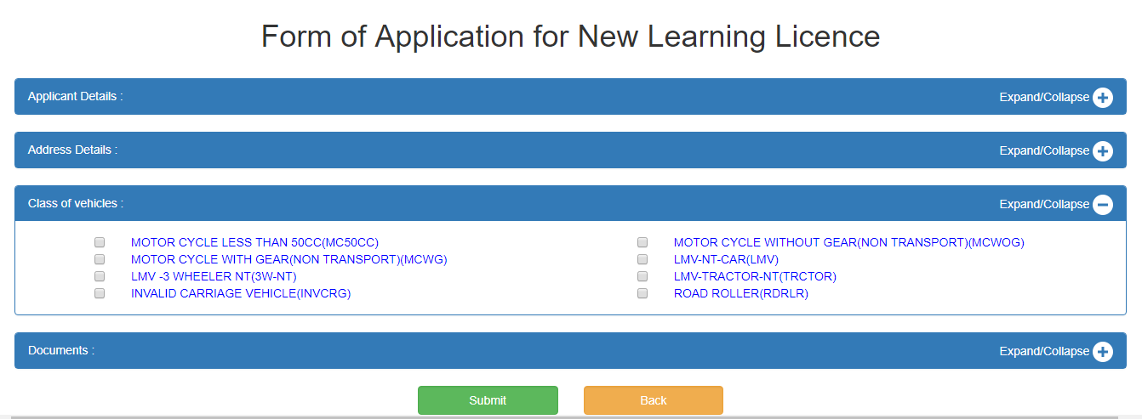

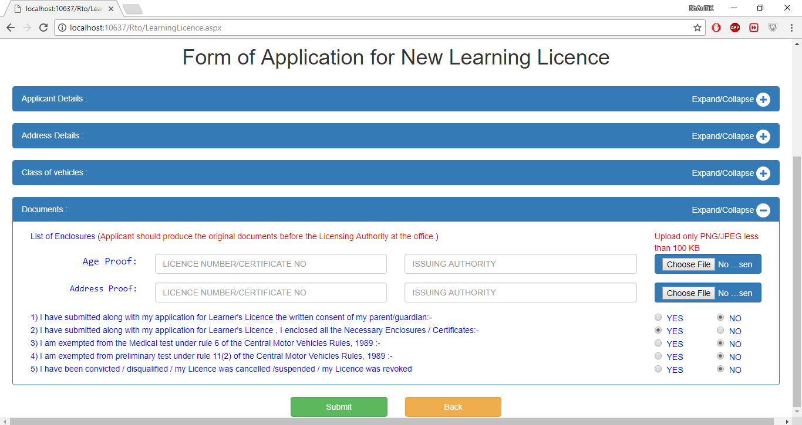

**Driving Licenses:**

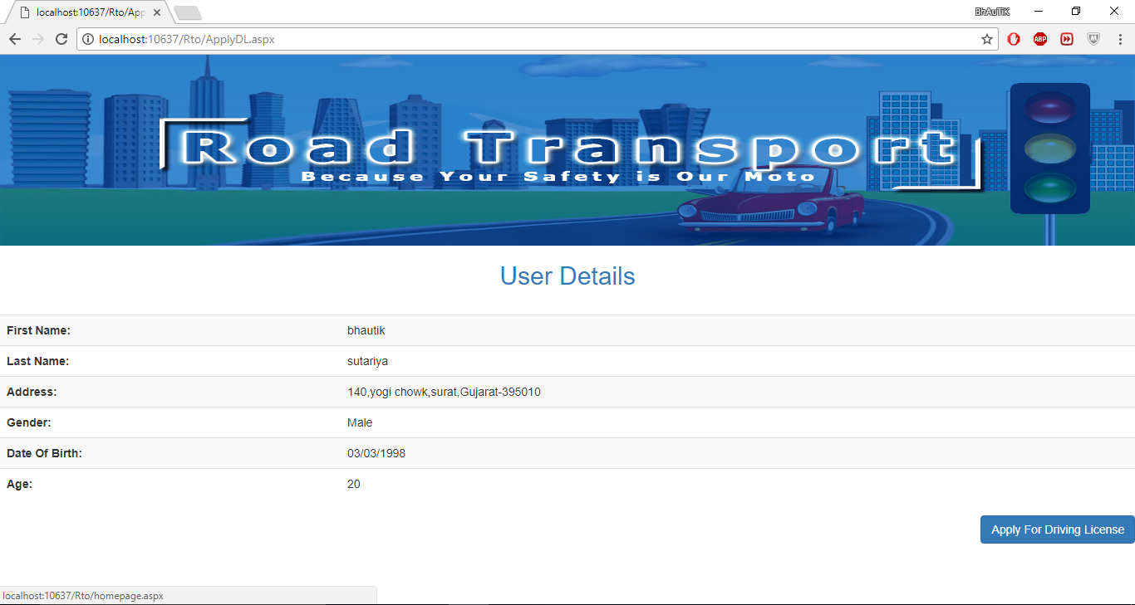

**Learning licenses status**

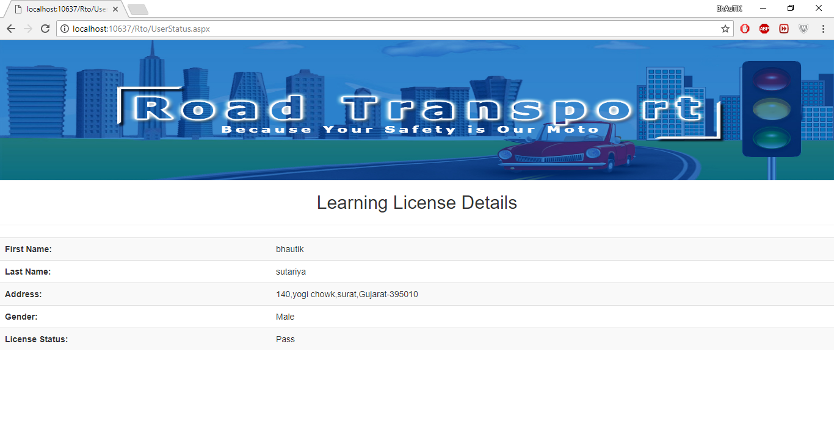

**Driving Licenses status:**

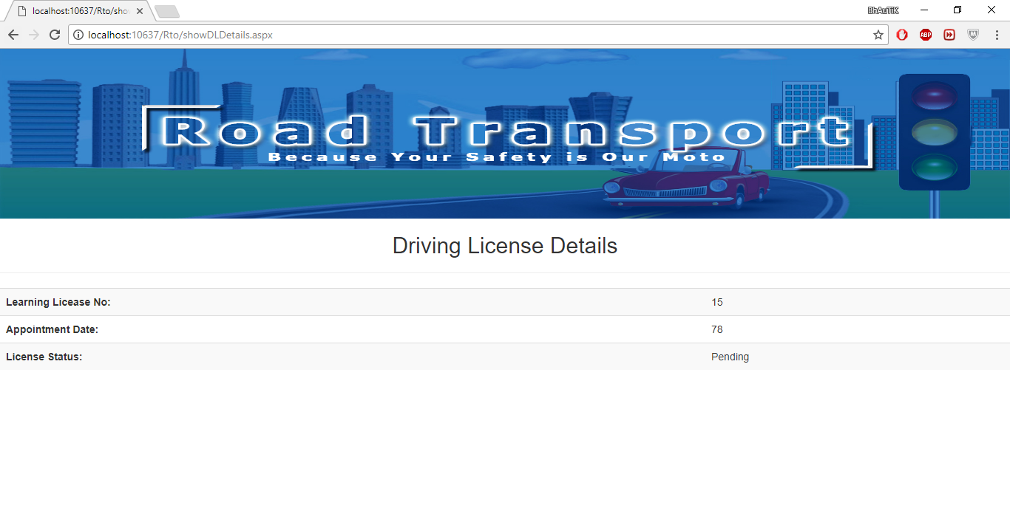

**Rto Details:**

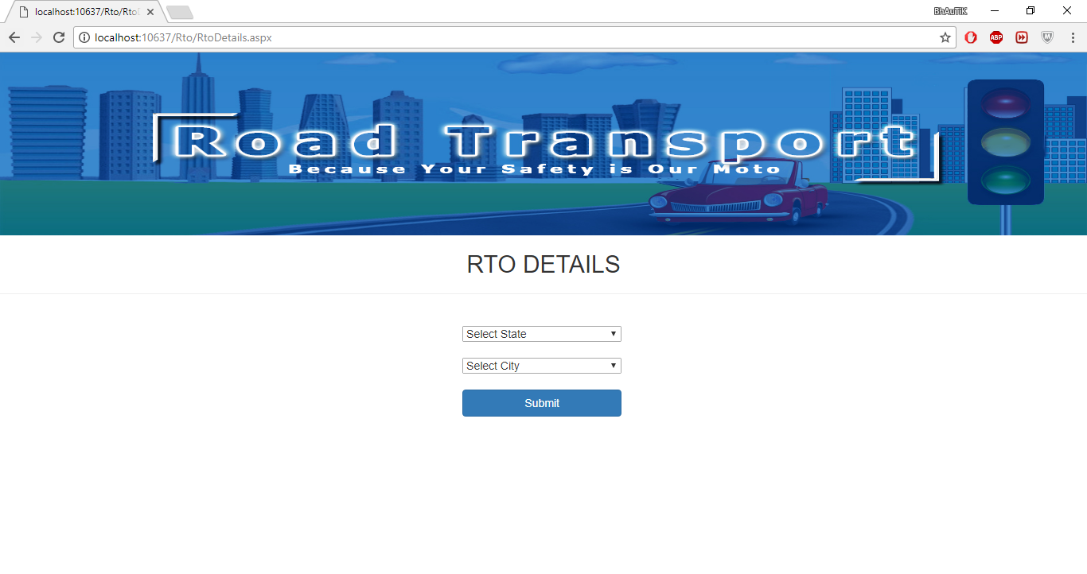

**Faqs:**

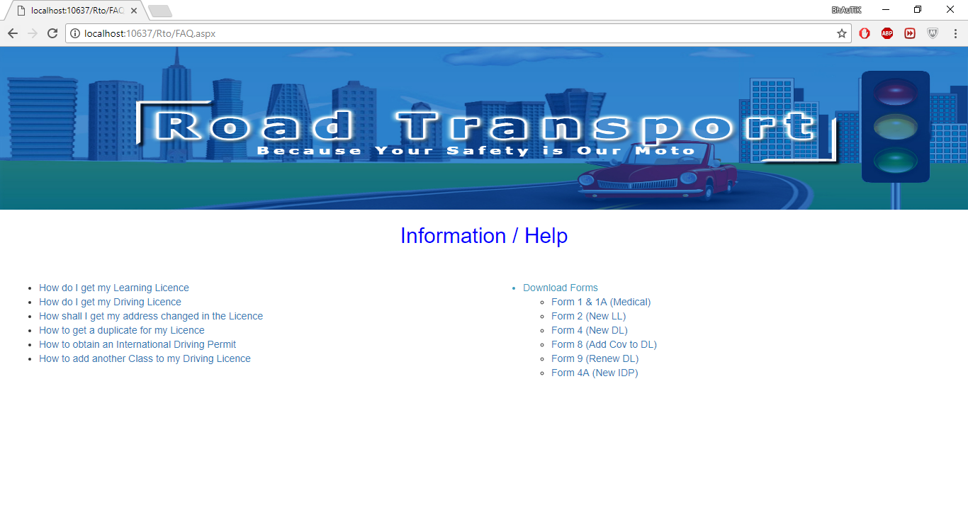

**Question Bank:**

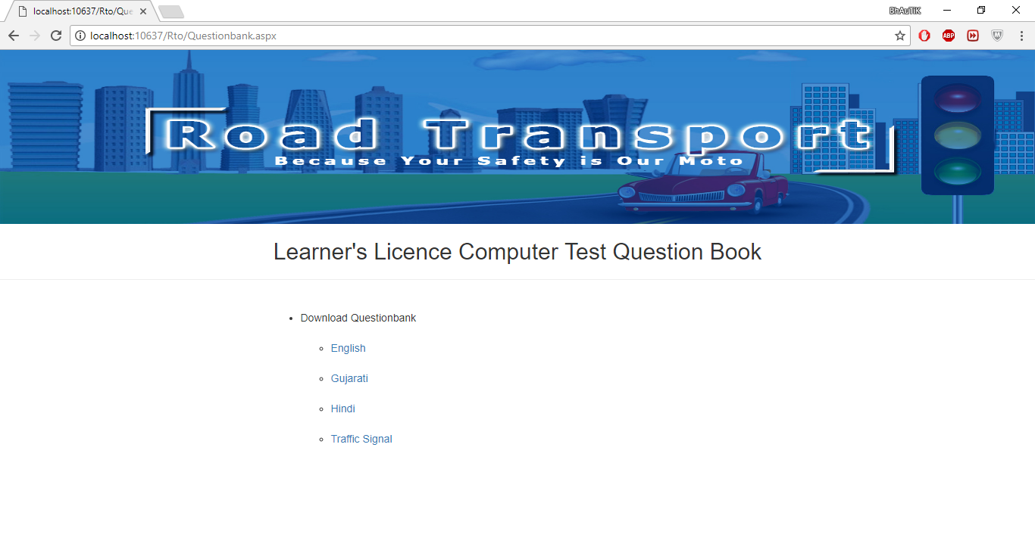

**Driving licenses video:**

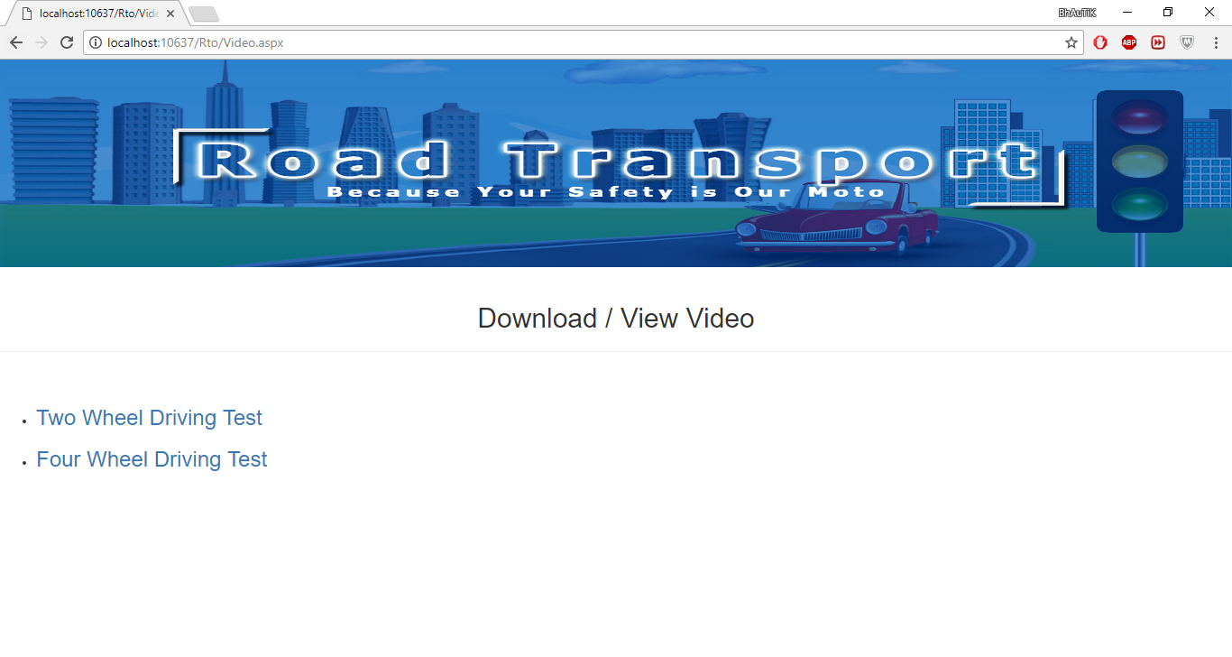

**Contact us:**

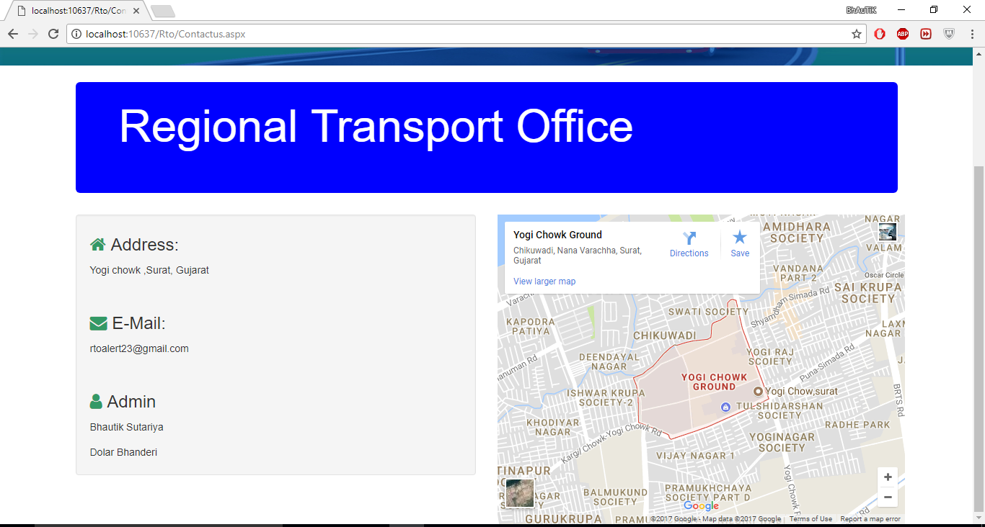

**Test Cases:**

**1 .Login validation:**

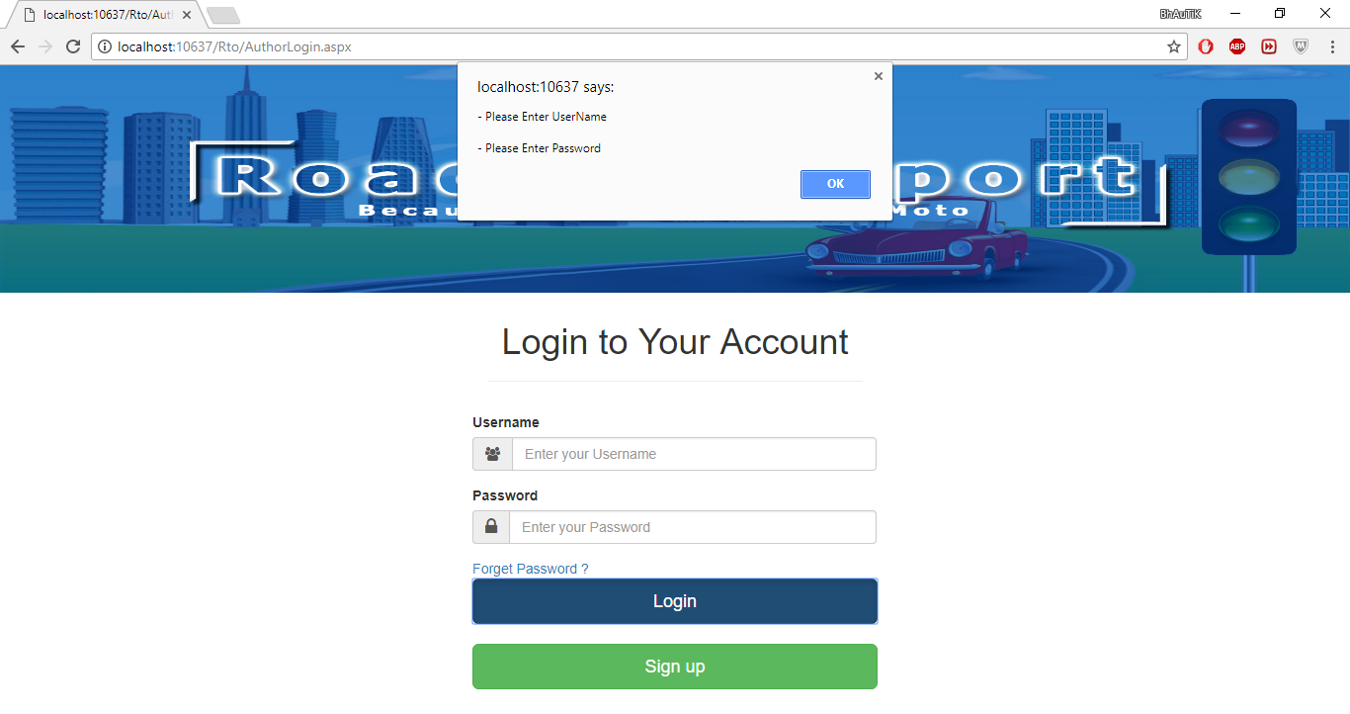

**2. Registration validation:**

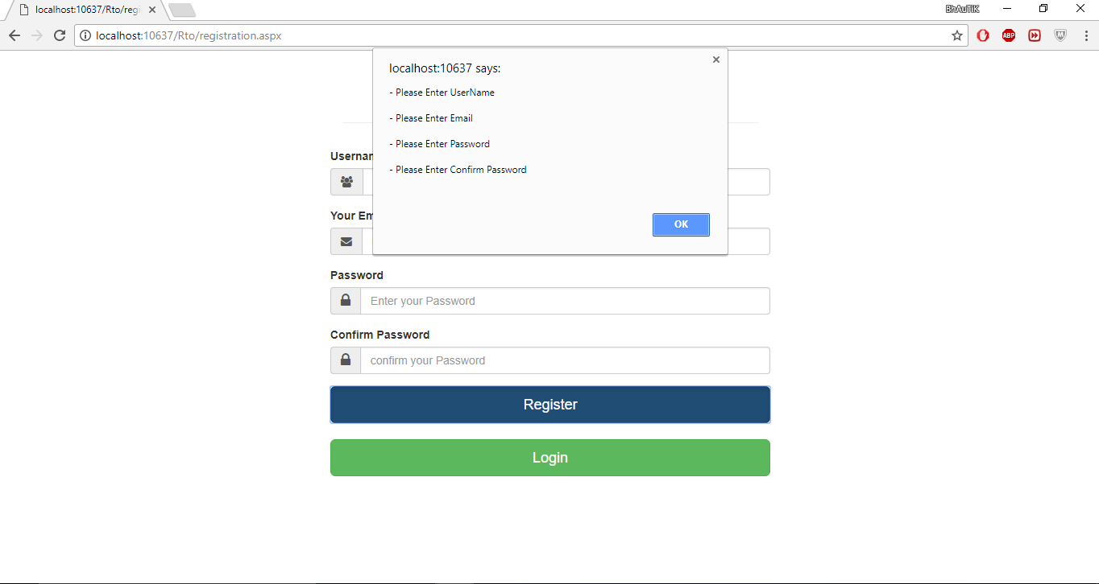

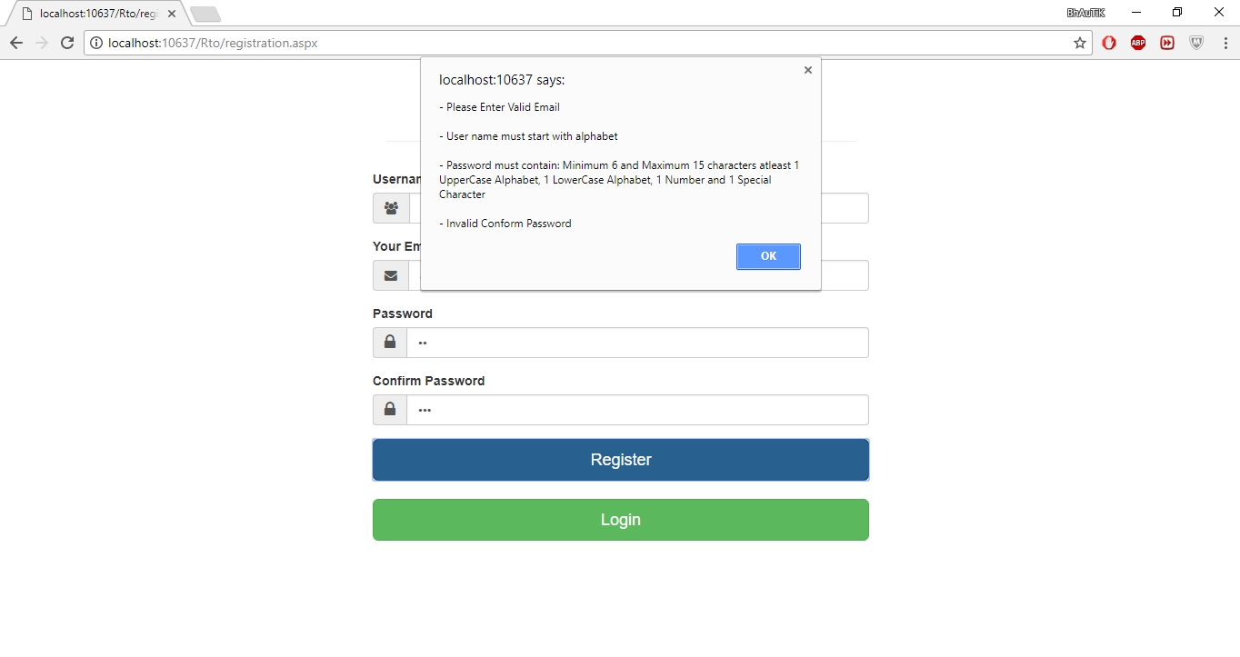

**Learning Licenses validation**

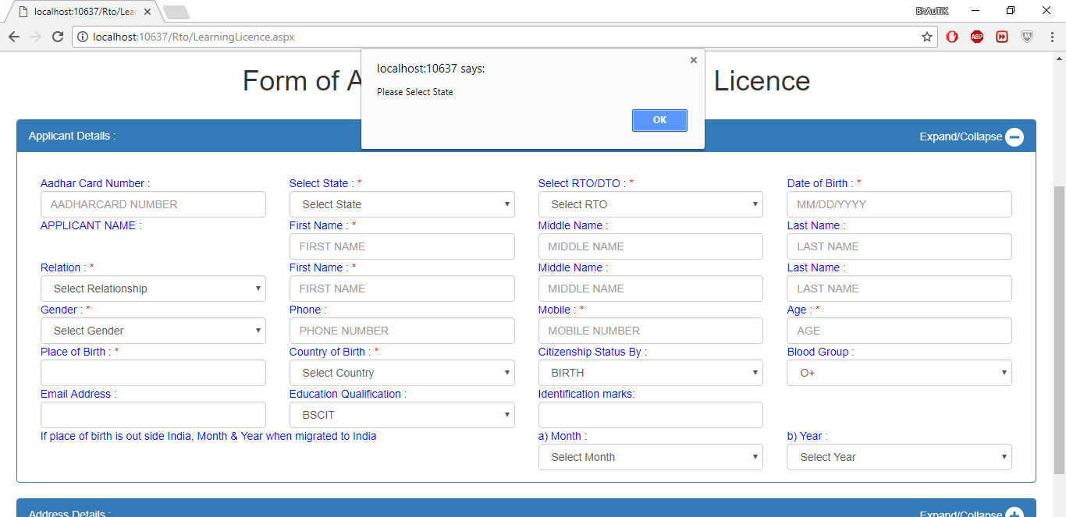

**Image validation:**

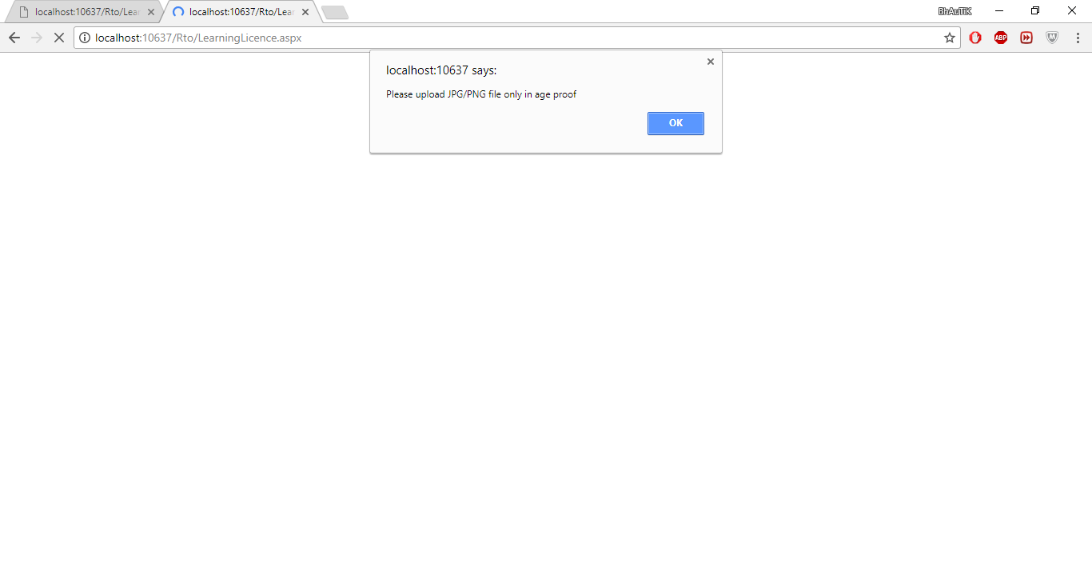

**Find Rto validation:**

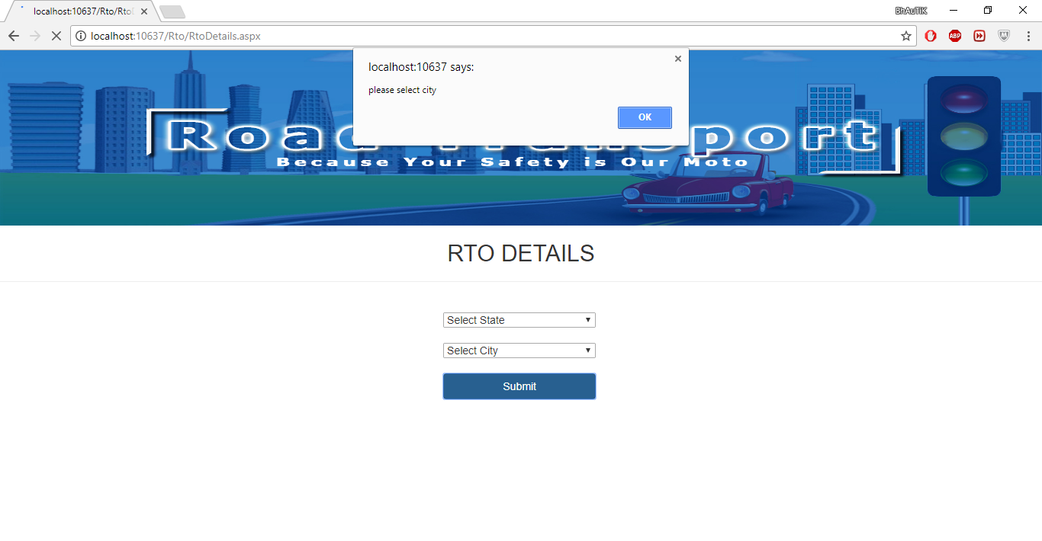

**Future Enhancement and conclusion:**

For future enhancement, Advertisement feature, renewal licenses module and

Vehicles slot booking facility will be implemented.

Project work challenge to us to think beyond the boundaries of the classroom, helping

Us to develop the skills, behaviors, and confidence necessary for success in the 21st-

Century

We have gained the knowledge of the Asp.net, MySQL in detail.

Project learning is a very important part of the curriculum.

**Learning During project work:**

At the time of project, learning is a very important part. It is essential to development of research skills, intelligent behaviors and thinking strategies. Occasions will arise where we have to deal with controversies, to identify and solve problems, to create new ideas, or to make difficult decisions.

There can be three stages in project working. Generally in the first level of activities, we selected a project with the help of the guide. After consulting the guide for guidelines, we embarked on the initial stage of reading for background information, researching and taking notes, building a reference list, taking trainings. Viewing videos, developing an outline, taking with peers and guide, surfing the internet, checking and double-checking sources, visiting sites and many more things.

As a project entered the second phase, we began to try to make sense of the information collected. We discovered that some information is relevant and some is not. At this level, we tried to analyze whatever information we have, sort the information into meaningful chunks and synthesize it in order to move the project forward.

At the third phase, I can divide the prioritized tasks, check time lines for the task any necessary emergency measures and stay alert. We performed activities like database design, user interface design, development, assembling, synthesizing ideas, rethinking or re-conceptualizing, finishing touches, decorative details, evaluative testing, peer review, self-assessment, evaluation criteria, expert review, final submittals ad celebrations.

For a success project learning experience, it is essential for us to have not only positive ‘I can’ attitude, but also the ‘I enjoy’ feeling. We will voluntarily continue to learn throughout a lifetime.

**Reference:**

* [www.google.com](http://www.google.com)
* http://www.youtube.com
* www.w3schools.com
* [www.stackoverflow.com](http://www.stackoverflow.com)
* <https://www.tutorialspoint.com/>
* sarthi.nic.in